OT-Hood Robot Only - Hood Set-Up

Learn how to set-up and fit your OT-Hood underneath the culture hood in your lab



Written by Opentrons

Updated this week

If you ordered an OT-One Hood, these pictures will show you how to take it apart in order to install it in your tissue culture hood.

Loosen bolts on pins in all four legs and slide them down.

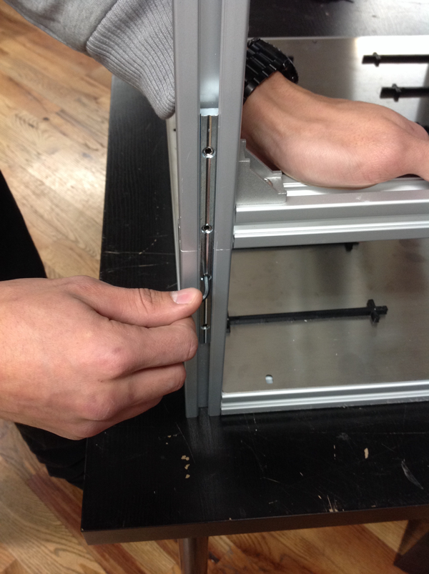

Slide down to this height.

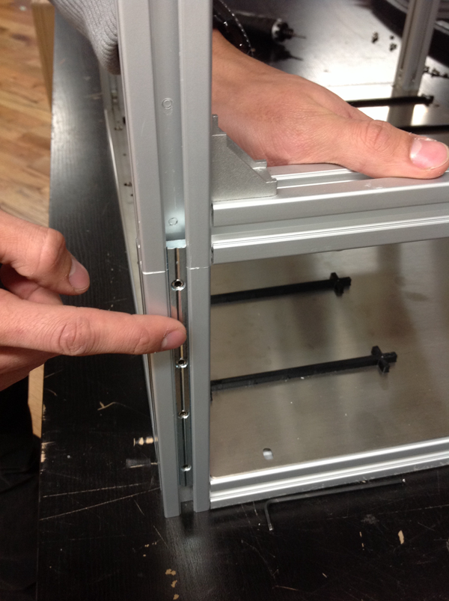

Lift the top piece off of the bottom piece using the black side handles.

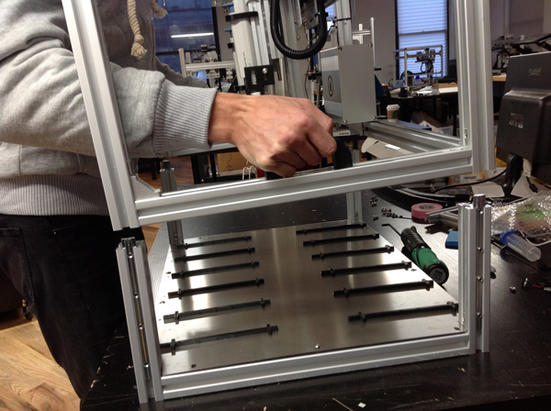

Slide both pieces underneath your culture hood and restack them.

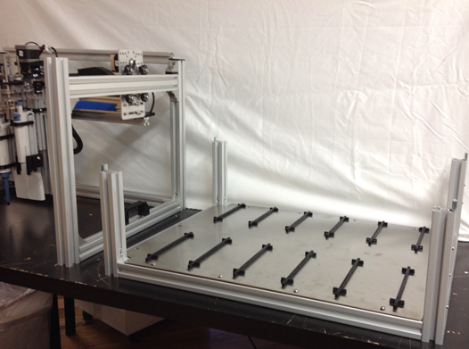

Once the pieces have been restacked in the hood, slide the bolts back up and tighten them to secure the robot.

